Smart Medication Reminder System

Program Definition:
Patients often forget to take their prescribed medications on time. Relying on memory or written schedules is unreliable, especially for those with multiple daily medications. This can cause missed doses, overdoses, or incorrect timing.

Objectives:
1)Build a simple software system that allows users to enter medications and schedule reminders.
2) Provide a list of upcoming medication times.
3) Use persistent storage so schedules are saved automatically.
4) Improve health safety by reducing missed medication doses.

Expected Outcomes:
- A functioning medication reminder program.
- Ability to add, view, update, delete medication schedules.
- Reminders shown in order of urgency.
- User-friendly interface.

Concepts Applied:
- Top-down system design
- Functions and modularization
- Data structures (lists, dictionaries)
- File handling (JSON)
- Basic validation + error handling
- Algorithm for sorting and scheduling

Requirement Analysis
Functional Requirements
- User can add medication: name, dosage, time of day.
- User can list all medications.
- User can delete or update a medication.
- System saves all medication data to file.
- System sorts medications by time.

Non – Functional Requirements
- Must be easy for elderly people to use.
- Must automatically load and save data.
- Must support 12-hour or 24-hour time formats.

Top-Down Design / Modularization:
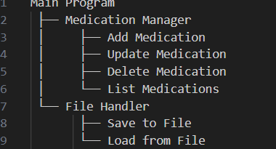

Algorithm Development
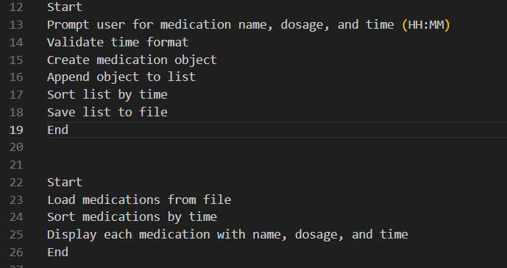

Implementation: 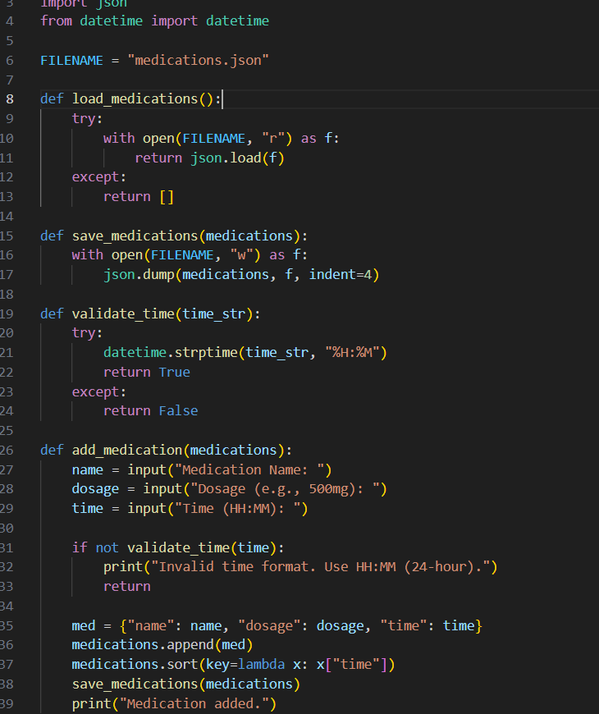
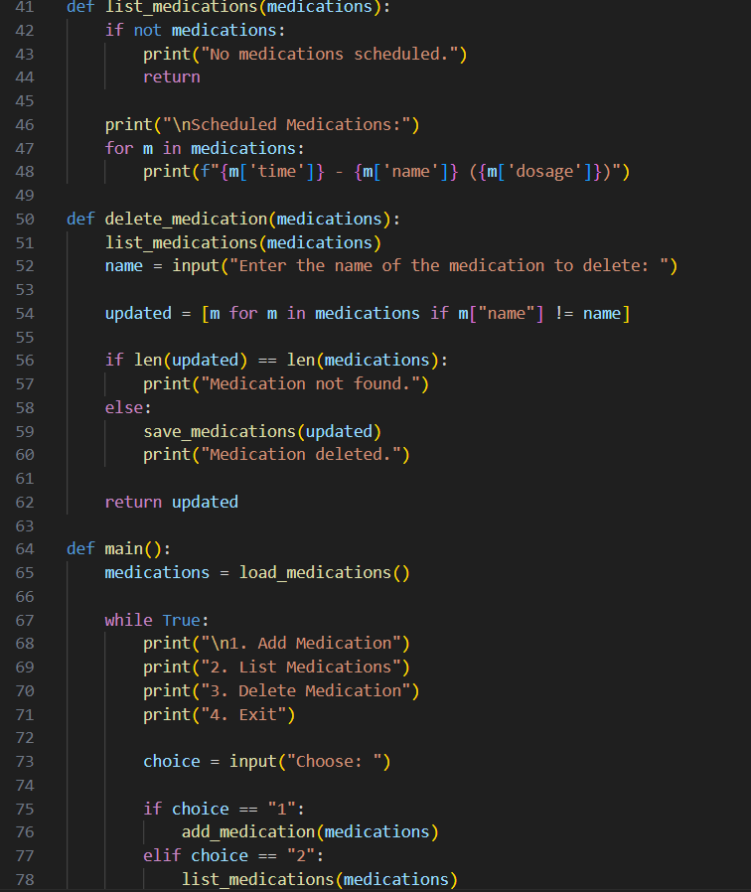
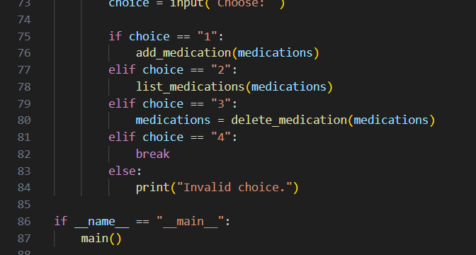

Testing and Refinement

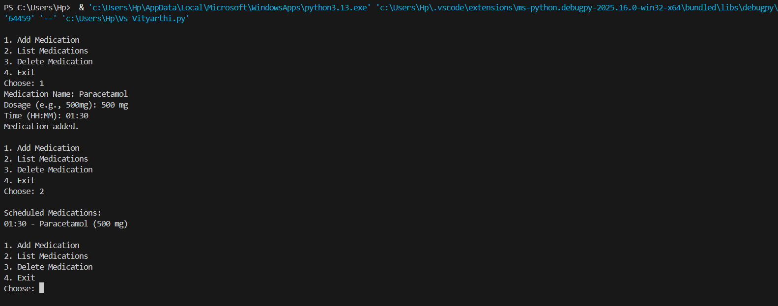
SOURCE CODE
